**Name = Nihar**

**Sap ID = 500091867**

**Roll No = R2142210525**

**Experiment No -2**

**Title** - **Implement the different Machine Learning on Weka Tool**

* **Analysing data in different views of relation contact-lenses, iris data**

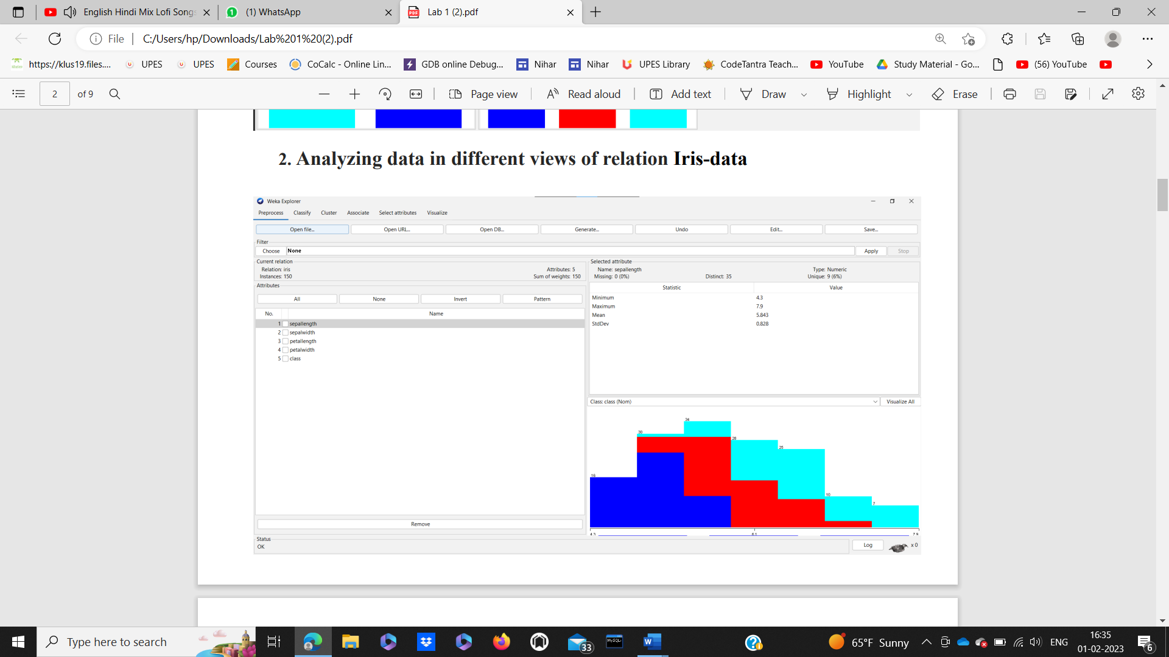

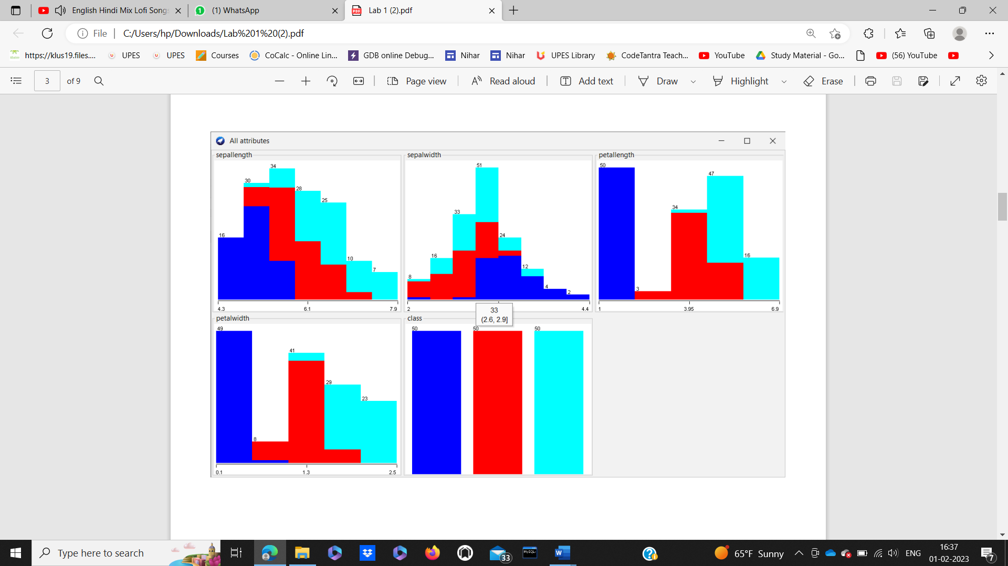

* **Classification**

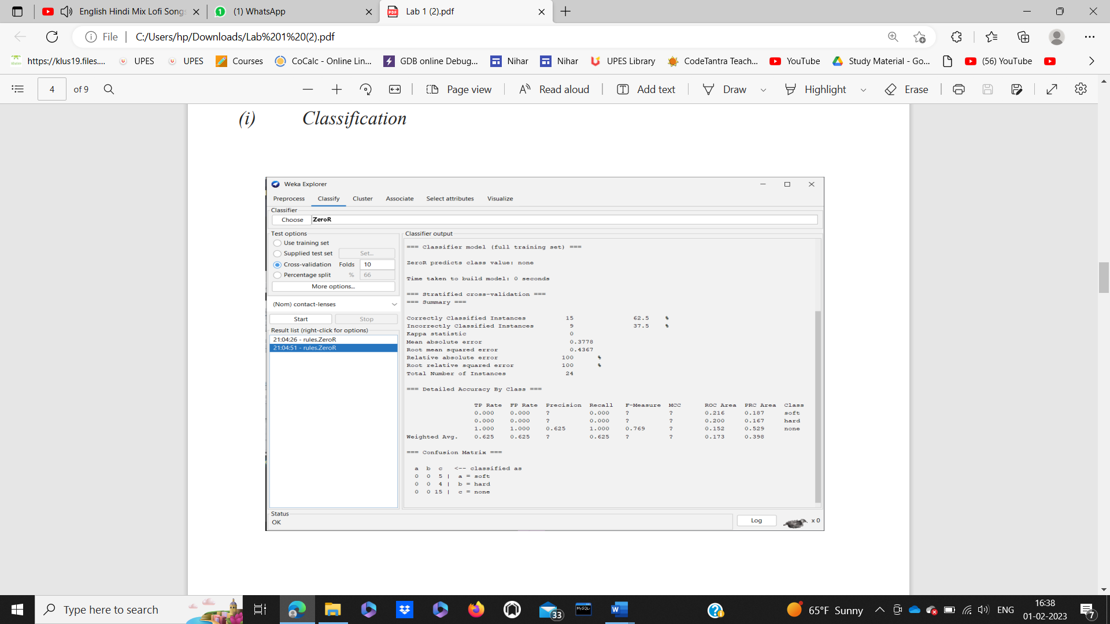

* 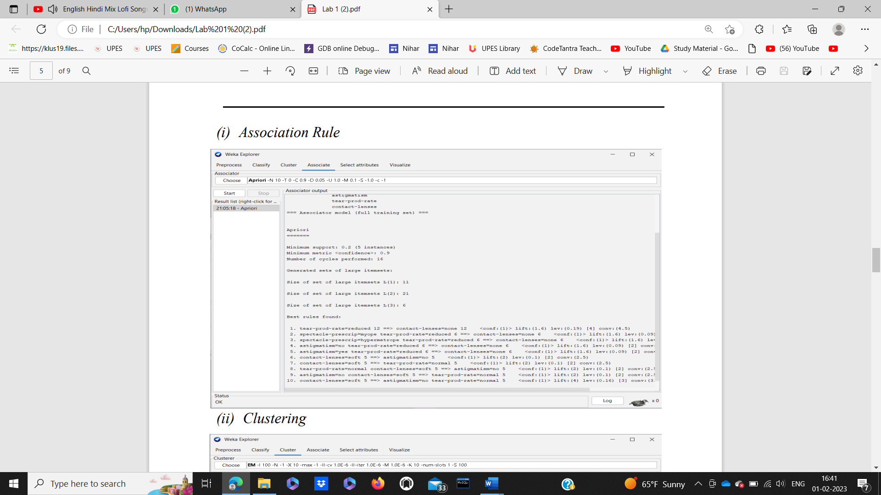**Association Rule**
* **Clustering**

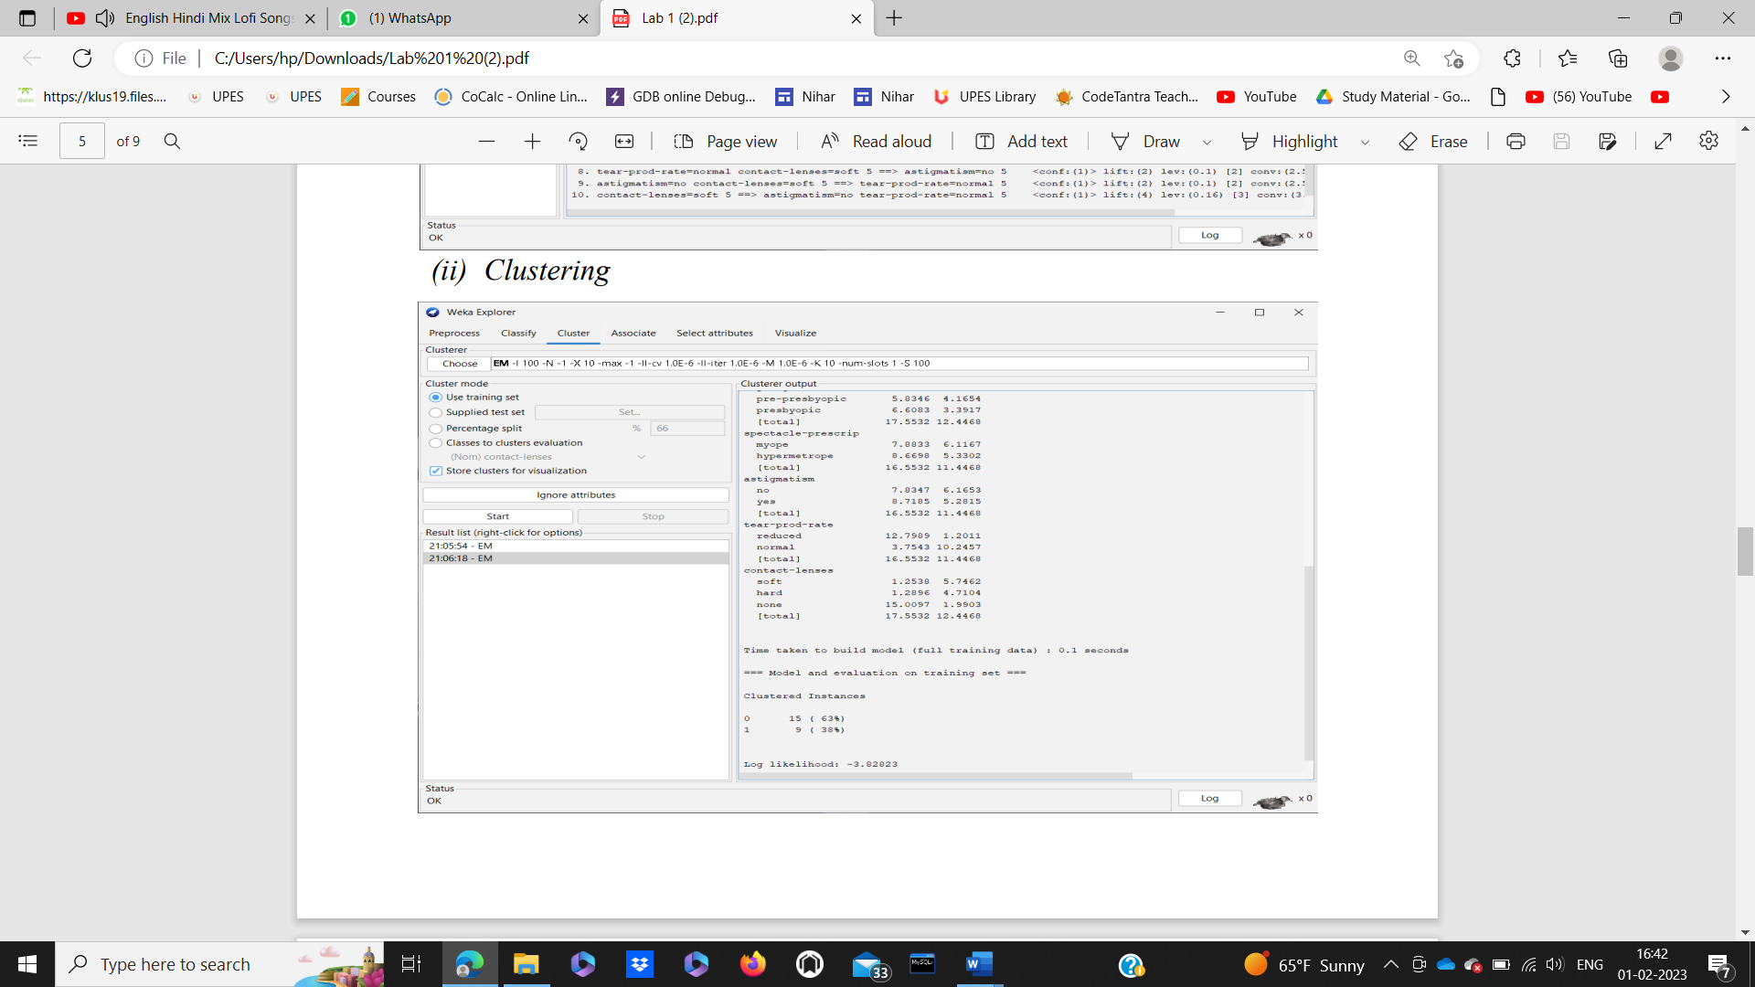

* **Visualize**

